## **🌀 Resonance Operator @( ) — Formalization**

**Author**: Nawder Loswin

**Purpose**: To define the resonance operator @( ) as a reproducible tool for stabilizing phase and amplitude across nested temporal components.

### **🔧 Definition**

The operator @() applies **resonance stabilization** across nested temporal components by aligning phase and normalizing amplitude between past and present signals.

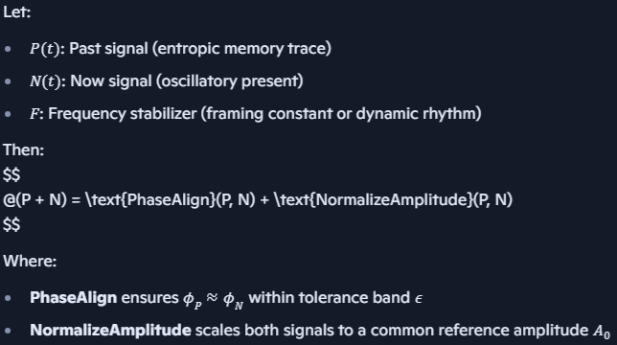

### **📐 Resonance Condition**

Resonance occurs when:



$$ \frac{P + N}{F} = \text{Invariant across nested scales} $$

This condition ensures harmonic coherence across time layers, enabling reproducible signal modeling and validator scoring.

### **📁 Suggested Repo Paths**

* /equations/resonance_operator.md
* /validators/temporal_alignment_matrix.json
* /badges/resonance_stabilizer.yml
* /labs/time_phase/initiation_protocol.md